For Sale BY OWNER

- 3.5% DOWN FINANCING AVAILABLE
- SELLER PAID CLOSING COSTS
- 15% BELOW MARKET VALUE
- $60,000 INSTANT EQUITY

Type:
Single Family Residence

Address:
164 S. Fur Street
Chandler, AZ 85226

Asking Price:
$348,500

Basic Details:
4 Bed/ 4 Bath
2500 Sq Ft
2 Car Garage
Built in 1985

HOA:
None
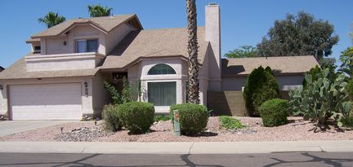
Other Amenities Include:
Fireplace, Pool, Spa/Jacuzzi, Central A/C, Main floor master bedroom, Separate shower & whirlpool tub. Lots of tile throughout. Great room with high ceilings and fireplace. Upstairs master bedroom has a patio door to a balcony, double vanity, cultured marble surround. Home is wired for cable in most rooms. New carpet and paint upstairs. Home is perfect for a home office.

Monthly Mortgage Payment of $1671

- 5.625% Interest Rate, 6.000% APR, 30 yr Fixed Mortgage
- Principal and Interest Payment, not including taxes and insurance
- Assumes 1% Origination Fee, 1% Discount Fee and 20% down payment
- Subject to qualification, rates and terms subject to change

